B-tree handout
for COMP378

Part 1: structure and algorithm
Consider the following B-tree of order 2/4.
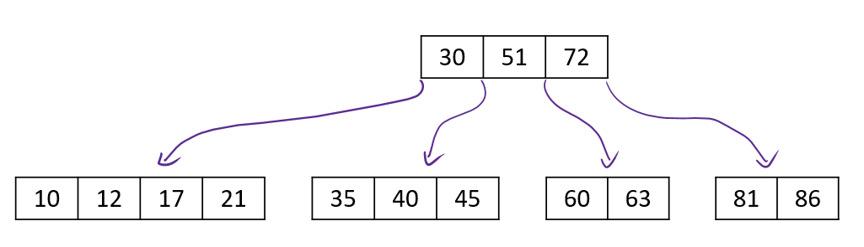
This can be represented as the following string:
30,51,72
10,12,17,21; 35,40,45; 60,63; 81,86
Give the diagrammatic or string representation of the B-tree at each stage of the following sequence of operations: insert 75, then 18, then 88, then 93.

Part 2: Accounting for disk blocks
Suppose a B-tree index is implemented on a device that has blocks of size 2 KiB. The node pointers are 32 bits, the data pointers are 48 bits, and the keys are 72 bits. What is the best choice for the order of the B-tree?

