Core content homework assignment 2 (CC2)

Part A

A1. (15 points) Download the file harvestfieldplant.sql from the link provided on the homework web pages. In phpMyAdmin, import the file harvestfieldplant.sql into a new database. You should see a database in phpMyAdmin with 3 tables named field_GH, harvested, and plant in the left-hand column. Submit a convincing screenshot as your answer to this question.

A2. (5 points) While viewing the harvestfieldplant database in phpMyAdmin, click on the Designer tab. You should see a graphical view of the three tables. The interface is a little flaky, but it is possible to drag these tables into different locations and to click on a small triangle next to each table to expand its description. Familiarize yourself with the interface and adjust the appearance until you obtain a view that looks similar to the following one:

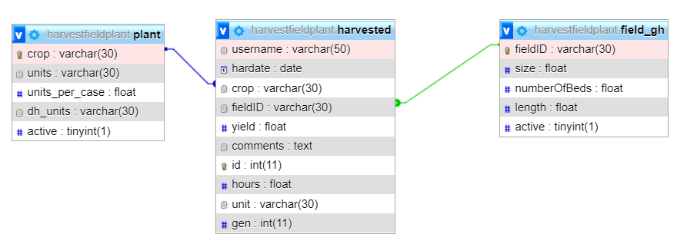

Submit your own screenshot, similar to the above, demonstrating that you have obtained the above view.

A3. (15 points) The lines in the above view indicate relationships between primary and foreign keys. For each table, explain which primary and/or foreign keys it has and what constraints that places on the values that can be stored in the table.

A4. (10 points) If you change the value of ‘fieldID’ in one of the rows of ‘field_gh’, it could change a value in one of the other tables. Explain why and give details. Demonstrate this effect in practice by making a suitable change to ‘field_gh’. Submit a screenshot showing the change that occurred in one of the other tables as a result.

A5. (0 points) Undo the change you made in the previous part of this question.

A6. (15 points; 3 points each) Answer questions 6.1 – 6.5 from the textbook.

A7. (20 points) Reconsider your EER model for textbook problem 3.4E, which you completed in the previous homework assignment. Describe a set of relational schemas that corresponds to your model. For example, here are schemas for the two entities from this problem that we modeled in class:

ARTIST(Name, Birthdate, URL)
SONG(SNO, Title, Length, Genre, ARTIST_Name)
ARTIST_Name: foreign key, refers to Name in Artist, NULL value not allowed

Recall that primary keys are underlined, and foreign keys are italicized.

A8. (15 points) Examine your model from the previous question and determine whether or not it is in 3NF. If it is not already in 3NF, make changes until it is. Describe any changes you make as part of your answer to this question. Once you believe that the model is in 3NF, give an informal justification explaining why the model is in 3NF. Two or three sentences should be sufficient for this.

The next few questions are based on a fictional database called ProgLang, which stores information about programming languages. At present, the ProgLang database schema consists of exactly one table called Language. Below are a few records taken from the Language table.

Language ID | Language name | Designer ID | Designer name | Designer institution | Era | Year released | Paradigm | ISO/IEC standard
201 | C | 772 | Dennis Ritchie | Bell Labs | mainframe | 1972 | imperative | 9899
939 | SQL | 201 | Donald Chamberlin | IBM | mainframe | 1974 | query | 9075
939 | SQL | 137 | Raymond Boyce | IBM | mainframe | 1974 | query | 9075
433 | CLU | 394 | Barbara Liskov | Massachusetts Institute of Technology | mainframe | 1975 | object-oriented | null
832 | C++ | 330 | Bjarne Stroustrup | Bell Labs | PC | 1985 | object-oriented | 14882
362 | Java | 244 | James Gosling | Sun | internet | 1995 | object-oriented | null

The assumptions behind the ProgLang database schema are as follows.
- Every programming language has a unique ID and name; the ISO/IEC standard numbers of programming languages are also unique but not every programming language has an ISO/IEC standard number.
- Every designer has a unique ID.
- The Era of a language depends on the year was released: before 1980 is the mainframe era, 1980-90 is the PC era, and after 1990 is the internet era.

A9. (10 points) The ProgLang database is not in BCNF. Explain why not, listing all violations of BCNF.

A10. (20 points) Describe how you would alter the ProgLang database schema so that it is in BCNF. Demonstrate the new schema by placing all information from the above six records of the Language table into your new schema’s tables.

The next few questions are based on a fictional database called CompAssignments, which stores information about the homework assignments given by a particular instructor in various computer science courses. At present, the CompAssignments database schema consists of exactly one table called Assignments. Below are a few records taken from the Assignments table.

assignment code  (C) | assignment type  (T) | course number  (N) | course area  (A)
CC2 | written | COMP378 | systems
RP1 | presentation | COMP378 | systems
CC2 | written | COMP314 | theory
RP1 | presentation | COMP314 | theory
PyLab4 | coding | COMP130 | intro
HW2 | written | COMP132 | intro

The assumptions behind the CompAssignments database schema are as follows.
- The course number $N$ uniquely determines the course area $A$.
- The assignment code $C$ uniquely determines the assignment type $T$.
- The combination of area $A$ and code $C$ uniquely determines the course number $N$. Note that this implies assignment codes are never reused within the same area. For example, it would be impossible for COMP132 to have an assignment PyLab4, because another intro course (COMP130) already has an assignment PyLab4.

A11. (10 points) The CompAssignments database is not in BCNF. Explain why not, listing all violations of BCNF.

A11. (5 points) The CompAssignments database is not in 3NF. Explain why not, listing all violations of 3NF. (Hint: The answers to this question and the previous question are not identical.)

A12. (10 points) Describe how you would alter the CompAssignments database schema so that it is in 3NF. Demonstrate the new schema by placing all information from the above six records of the Assignments table into your new schema’s tables.

A13. (5 points) The new version of the CompAssignments database (which you described in your answer to the previous question) is not in BCNF. Explain why not, listing all violations of BCNF.

A14. (5 points) In fact, it is impossible to put CompAssignments into BCNF. In one sentence of your own words, give an informal explanation of why this is impossible.

Part B

For each of the following descriptions, give an SQL query that would return the desired result from the wine database.

B1. (5 points) The number of purchase orders in the system.

B2. (5 points) The number of different products currently ordered. Each product should be counted only once.

B3. (5 points) The total quantity of products currently ordered.

B4. (5 points) The longest delivery period of any product from any supplier.

B5. (5 points) The number of different products whose available quantity is known.

B6. (5 points) The average price of products. (More accurately, this will be the average of all prices for each combination of supplier and product that has a known price.)

B7. (5 points) The average delivery period for each supplier in descending order. Each average delivery period should be listed with the corresponding supplier number.

B8. (5 points) The total available quantity of each product type (red, white, rose, and sparkling). Each total should be listed with the corresponding product type.

B9. (5 points) The total quantity of products ordered in each purchase order whose total quantity is greater than 17. Each total should be listed with its corresponding purchase order number.

B10. (5 points) The name and city of each supplier, in alphabetical order by city.

Total points on this assignment: 130

